Creating a User Control

1. Open Visual Studio and create a new website

2. Add New Item. In the Add New Item dialog box, select **Web User Control**. Name it **AddressUserControl.ascx**.

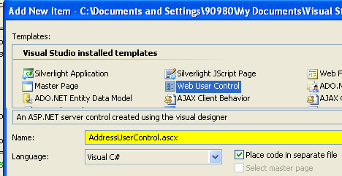

3. Open the user control and add input elements to the markup for address, city, state/ province, and postal code.

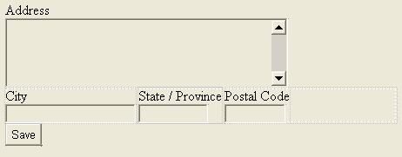

Your control markup should look similar to the following.

<%@ Control Language="C#" AutoEventWireup="true" CodeFile="AddressUserControl.ascx.cs" Inherits="AddressUserControl" %>

<div>

Address

<br />

<asp:TextBox ID="TextBoxAddress" runat="server" Width="325px" Height="80px"

TextMode="MultiLine"></asp:TextBox>

<div style="width: 450px">

<div style="float: left; margin-right: 3px">

City

<br />

<asp:TextBox ID="TextBoxCity" runat="server" Width="150"></asp:TextBox>

</div>

<div style="float: left; margin-right: 3px">

State / Province

<br />

<asp:TextBox ID="TextBoxStateProv" runat="server" Width="80"></asp:TextBox>

</div>

<div style="float: left">

Postal Code

<br />

<asp:TextBox ID="TextBoxPostalCode" runat="server" Width="70"></asp:TextBox>

</div>

</div>

<asp:Button ID="ButtonSave" runat="server" Text="Save" onclick="ButtonSave_Click" />

</div>

4. Open the code-behind file and add properties to expose the Text property of the user control’s TextBox controls.

public partial class **AddressUserControl** : System.Web.UI.UserControl

{

public string Address

{

get { return TextBoxAddress.Text; }

set { TextBoxAddress.Text = value; }

}

public string City

{

get { return TextBoxCity.Text; }

set { TextBoxCity.Text = value; }

}

public string StateProvince

{

get { return TextBoxStateProv.Text; }

set { TextBoxStateProv.Text = value; }

}

public string PostalCode

{

get { return TextBoxPostalCode.Text; }

set { TextBoxPostalCode.Text = value; }

}

}

5. Next, you will define the event handler for the Save button. This event will raise an event to the host of the user control. Given that the user control already exposes properties for reading its values, the event will not pass them as an argument; it will simply raise a generic event. Add the event declaration to the user control’s code-behind class file.

This code should read as follows.

public event EventHandler SaveButtonClick;

6. Finally, add code to the button’s click event that raises this event. The following is an example.

public event EventHandler SaveButtonClick;

protected void ButtonSave_Click(object sender, EventArgs e)

{

if (SaveButtonClick != null)

SaveButtonClick(this, new EventArgs());

}

6. Open the Default.aspx page in Design view. Delete the content inside the MainContent control. While still in Design view, drag AddressUserControl.ascx to the page from Solution Explorer.

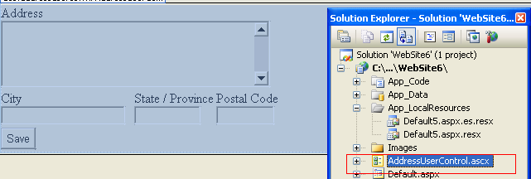

7. Change to Source view for the page. Start typing inside the control’s tag. Notice that you can initialize the control’s custom properties through markup and that IntelliSense is fully aware of these properties and even offers them to you as it would any other standard ASP.NET property. These properties are also available in the Properties window in Design view.

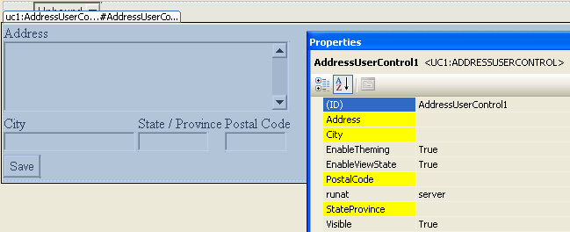

4. In this step, you add an event handler to trap the event fired by the user control when a user clicks the Save button. Start by opening the code-behind file for the Default.aspx page.

protected void Page_Init(object sender, EventArgs e)

{

AddressUserControl1.SaveButtonClick += this.AddressUserControl1_SaveButtonClick;

}

You will receive an error because you must create the function as it is shown in the next step

5. You now need to add code to the intercepted event. For this example, this code will simply take the user’s input and write it out to the debug window. The following shows an example.

protected void AddressUserControl1_SaveButtonClick(object sender, EventArgs e)

{

System.Diagnostics.Debug.WriteLine("Address: " + AddressUserControl1.Address +

" City: " + AddressUserControl1.City +

" State : " + AddressUserControl1.StateProvince +

" Postal Code: " + AddressUserControl1.PostalCode);

}

6. Initialize variables in the control from the page

protected void Page_Load(object sender, EventArgs e)

{

if (!IsPostBack)

{

AddressUserControl1.Address = "Res. Primavera";

Page.DataBind();

}

}

7. Finally, run the application in debug mode to view the results.

- Enter address information in the user control.

- Click the Save button.

- Return to Visual Studio and view the Output window (View | Output) to see the results.

